Assignment – 12 (IN, ANY, ALL)
1️. Write a query that selects all customers whose ratings are greater than or equal to any rating belonging to the customer named Serres.
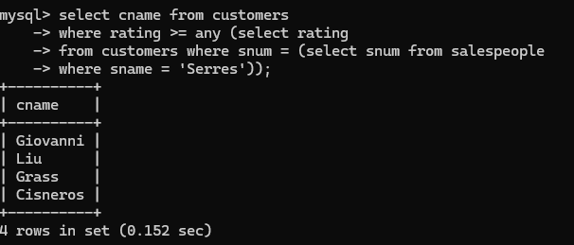
2️. Write a query using ANY or ALL to find all salespeople who do not have any customers living in the same city as they do.
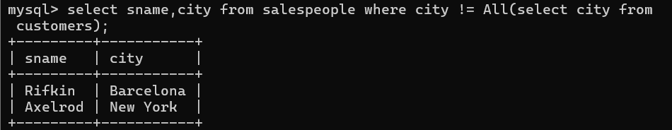
3️.Write a query that selects all orders whose amounts are greater than any order amount placed by customers located in London.
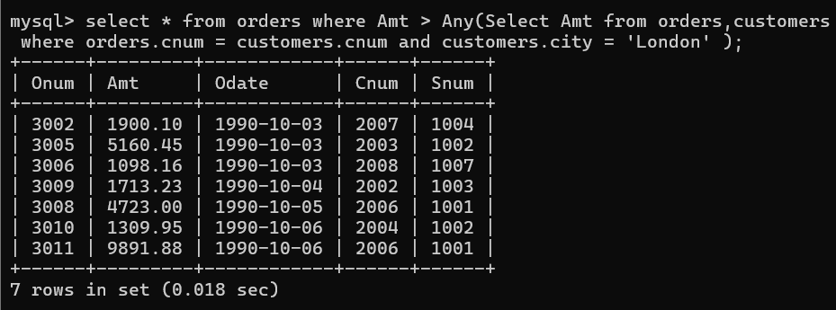

4️. Rewrite Question 3 using the MIN or MAX function instead of ANY.
